Name _______________________________________ Date ______________________

Trimester 3 Due Date _____________________

**Math 7 – Chapter 7 – Surface Area and Volume**

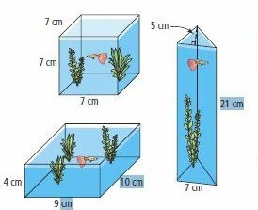 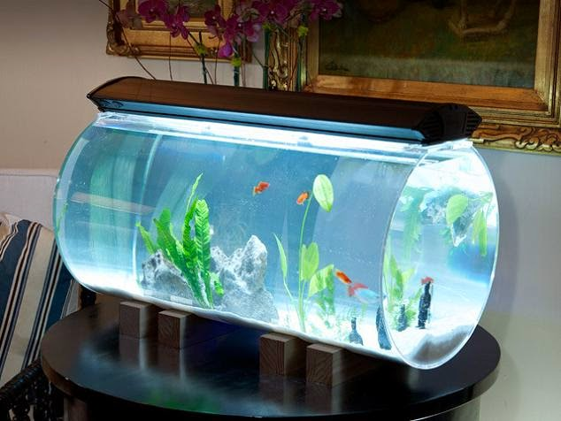

1. Design a themed aquarium using two or more solid figures. On your sketch, label each dimension and be prepared to present your drawing to the class. (Use prisms, pyramids, cones, and/or cylinders.)
2. Get creative! Bring your design to life. Construct the aquarium using household items. This project should be low to no cost for you. Finished products should be no larger than a base size of 24 in. by 18 in. so that they fit on your desk top.
3. Use the dimensions of your figures to determine volume. Be sure your work is neat and clear. Show your data and calculations. Write any explanations that you think are necessary.

Are your calculations correct? Is your drawing clearly presented? If necessary, make changes to improve your aquarium.

Rubric

________/10 Sketched aquarium is clearly labeled with dimensions of two figures

________/10 Creative construction of aquarium (two or more 3D shapes used)

________/30 Student has constructed a table that displays the following with accuracy for each figure:

Shape of base(s), dimensions of base, area of base, height of solid, volume, name of geometric solid

_______/50 Total points earned